KINGSTON ENGINEERING COLLEGE

COLLEGE CODE - 5113

**S. UDAYA KUMAR - (511321106023)[- udayakumar190704@gmail.com](mailto:-%20udayakumar190704@gmail.com) (team head)**

**S. CHANDRU - (511321106006)[- cc7442120@gmail.com](mailto:-%20cc7442120@gmail.com)**

**R. JEEVAN - (511321106013)[- rjeevan.ramachandran@gmail.com](mailto:-%20rjeevan.ramachandran@gmail.com)**

**S. VIGNESH - (511321106025)[- vigneshs4104@gmail.com](mailto:-%20vigneshs4104@gmail.com)**

# **PROJECT TITLE:**

**AI BASED DIABETES PREDICITION SYSTEM**

**PHASE -5**



**INTRODUCTION:**

An AI-based diabetes prediction system leverages the power of artificial intelligence and machine learning algorithms to analyze diverse sets of data, including medical records, lifestyle factors, genetic predispositions, and more, to predict an individual's risk of developing diabetes. These systems aim to provide timely and accurate predictions, enabling proactive interventions and lifestyle modifications to mitigate the risk or manage the condition effectively.

This introduction will provide an overview of the key components and benefits of an AI-based diabetes prediction system, highlighting its potential to revolutionize diabetes prevention and management.

Key Components of an AI-Based Diabetes Prediction System:

1. **Data Collection**: The foundation of any AI-based prediction system is data. These systems gather comprehensive data from various sources, such as electronic health records, wearable devices, patient questionnaires, and genetic information. This data includes demographic information, medical history, glucose levels, physical activity, dietary habits, and family history.
2. **Data Preprocessing**: Raw data collected from different sources often need preprocessing to ensure consistency and reliability. Data preprocessing involves cleaning, aggregating, and transforming data into a suitable format for analysis.
3. **Feature Selection**: Identifying relevant features or variables from the dataset is crucial for model accuracy. Machine learning algorithms are used to determine which features contribute the most to predicting diabetes risk.
4. **Machine Learning Algorithms**: AI-based diabetes prediction systems utilize a variety of machine learning algorithms, such as logistic regression, support vector machines, decision trees, and deep learning models (e.g., neural networks). These algorithms learn from historical data and use it to make predictions about an individual's likelihood of developing diabetes.
5. **Model Training**: Machine learning models are trained on historical data to learn the patterns and relationships between different variables. The quality and size of the training dataset play a significant role in the model's accuracy.
6. **Predictive Scoring**: After model training, the system assigns predictive scores to individuals, indicating their risk level. These scores help healthcare professionals prioritize interventions and preventive measures.

Benefits of an AI-Based Diabetes Prediction System:

1. **Early Detection**: AI-based systems can identify individuals at risk of diabetes before symptoms manifest. Early detection allows for timely interventions and lifestyle modifications that can prevent or delay the onset of the disease.
2. **Personalized Recommendations**: By analyzing individual data, these systems can provide personalized recommendations for diet, exercise, and medication management, optimizing diabetes prevention and management plans.
3. **Improved Healthcare Resource Allocation**: Healthcare providers can use the system to allocate resources more efficiently by focusing on high-risk individuals, reducing the burden on healthcare facilities.
4. **Research Insights:** AI-based diabetes prediction systems can provide valuable insights into the factors contributing to diabetes development, aiding in further research and understanding of the disease.

Top of Form

**Specification:**

**1. Data Collection**:

* + Gather a comprehensive dataset containing relevant information about individuals, including features like age, gender, family history, BMI (Body Mass Index), blood pressure, glucose levels, and other medical history.
  + Ensure the dataset is labeled, with a target variable indicating whether each individual has diabetes or not.

1. **Data Preprocessing**:
   * Handle missing data by imputation or removal.
   * Normalize or standardize features to ensure they are on the same scale.
   * Encode categorical variables if necessary.
   * Split the dataset into training and testing sets to evaluate the model's performance.
2. **Feature Selection**:
   * Identify which features are most relevant for predicting diabetes using techniques like feature importance or feature selection algorithms.
3. **Model Selection**:
   * Choose an appropriate machine learning algorithm for classification tasks. Common choices include:
     + Logistic Regression
     + Decision Trees
     + Random Forest
     + Support Vector Machines (SVM)
     + Neural Networks
4. **Model Training**:
   * Train the selected model on the training dataset.
   * Tune hyperparameters to optimize model performance, which may involve techniques like cross-validation.
5. **Model Evaluation**:
   * Evaluate the model using metrics such as accuracy, precision, recall, F1-score, and AUC-ROC on the testing dataset to assess its predictive performance.
6. **Deployment**:
   * Integrate the trained model into an application or system where it can make predictions.
   * Create a user-friendly interface for users to input their data.
7. **Monitoring and Updates**:
   * Continuously monitor the model's performance in a real-world setting.
   * Retrain the model periodically using new data to keep it up to date and accurate.
8. **Ethical Considerations**:
   * Ensure that the AI system complies with ethical guidelines and data privacy regulations.
   * Address potential biases in the data and model to avoid unfair predictions.
9. **User Education**:
   * Educate users about the limitations of the AI system and the importance of consulting with healthcare professionals for medical advice.

**Purpose of diabetes prediction:**

Early detection,Preventive Healthcare, Improved Patient Outcomes, Resource Optimization,Reducing the Burden of Disease, Reducing the Burden of Disease, Data-Driven Insight, Long-Term Health Monitoring and Telemedicine and Remote Monitoring.

**Preprocessing the dataset**:

Here is an overwiew of dataset preprocessing in diabetes prediction system:

**Data Collection:**

Gather a comprehensive dataset of patient information, including factors like age, BMI, family history, diet, physical activity, and previous medical records.

**Data Preprocessing:**

Clean, preprocess, and normalize the data to ensure consistency and remove any outliers or missing values.

**Feature Selection:**

Determine which features are most relevant for diabetes prediction. Feature engineering may also be necessary to create new informative variables.

**Model Selection**:

Choose an appropriate machine learning or deep learning algorithm for your prediction task. Common choices include logistic regression, decision trees, random forests, or neural networks.

**Training the Model**:

Split your dataset into training and testing sets to train and evaluate the model's performance. Fine-tune hyperparameters and optimize the model.

**Validation**:

Use k-fold cross-validation to validate the model's performance. This helps ensure that the model generalizes well to new data.

**Evaluation Metrics**:

Select appropriate evaluation metrics like accuracy, precision, recall, F1-score, and ROC-AUC to assess the model's performance.

**Deployment**:

Develop a user-friendly interface for the prediction system, whether it's a web application or a mobile app. Make sure the model can be easily integrated into the system.

**Privacy and Security:**

Ensure that patient data is handled securely and in compliance with data protection regulations.

**Continuous Improvement:**

The model should be periodically updated with new data to improve its accuracy over time.

**Interpretability:**

Consider using techniques to make the model's predictions interpretable, especially in healthcare applications where transparency is crucial.

**Ethical Considerations:**

Be mindful of the ethical implications of your AI system, especially when dealing with sensitive medical data.

**Regulatory Compliance:**

Ensure that your system complies with relevant healthcare and data privacy regulations, such as HIPAA in the United States.

**Collaboration with Healthcare Professionals:**

Collaborate with healthcare experts to validate the model's predictions and gain insights from their domain knowledge.

**Documentation and Reporting:**

Document the entire development process, model architecture, and results. This is essential for future reference and publication.

**User Education:**

Educate users, such as healthcare providers, on how to interpret and use the system's predictions effectively.

**Feedback Mechanism:**

Implement a feedback mechanism to collect user feedback and continually improve the system

**Requirements:**

*Machine learning framework

*Algorithm selection

*Pandas

*Numpy

*Scalability

**Source code**:

# Import necessary libraries

import numpy as np

import pandas as pd

from sklearn.model_selection import train_test_split

from sklearn.ensemble import RandomForestClassifier

from sklearn.metrics import accuracy_score

# Load the diabetes dataset (you should replace this with your own dataset)

# You can find diabetes datasets from various sources, such as UCI Machine Learning Repository.

# For this example, I'm using the diabetes dataset from scikit-learn.

from sklearn.datasets import load_diabetes

data = load_diabetes()

X, y = data.data, data.target

# Split the data into training and testing sets

X_train, X_test, y_train, y_test = train_test_split(X, y, test_size=0.2, random_state=42)

# Create a Random Forest classifier (you can experiment with different algorithms)

clf = RandomForestClassifier(n_estimators=100, random_state=42)

# Train the model on the training data

clf.fit(X_train, y_train)

# Make predictions on the test data

y_pred = clf.predict(X_test)

# Calculate accuracy

accuracy = accuracy_score(y_test, y_pred)

print(f"Accuracy: {accuracy * 100:.2f}%”)

**Procedure :**

**1. Define the Objective**:

- Clearly define the purpose and goals of the diabetes prediction system. What type of diabetes are you aiming to predict? Type 1, Type 2, or both? What outcomes are you looking to achieve (e.g., early detection, risk assessment, preventive recommendations)?

**2. Data Collection:**

- Gather a comprehensive dataset containing relevant information for the prediction task. This dataset may include:

- Medical records, including patient history, lab results, and medications.

- Lifestyle and behavioral data (e.g., diet, physical activity, smoking habits).

- Genetic information, if available.

- Socioeconomic and demographic data.

- Data from wearable devices, if applicable.

**3. Data Preprocessing**:

- Clean the data to remove missing values, outliers, and inconsistencies.

- Standardize or normalize numerical features.

- Encode categorical variables.

- Split the dataset into training, validation, and test sets.

4. **Feature Selection/Extraction:**

- Identify relevant features and reduce dimensionality if necessary.

- Explore feature engineering techniques to create new variables that may improve prediction accuracy.

5. **Model Selection:**

- Choose the appropriate machine learning or deep learning algorithms for the task. Common choices include logistic regression, decision trees, random forests, support vector machines, and neural networks.

6. **Model Training:**

- Train the selected model(s) on the training dataset. Optimize hyperparameters to improve performance.

- Evaluate the model's performance on the validation set, using metrics like accuracy, precision, recall, and F1-score.

7. **Model Evaluation:**

- Assess the model's performance on the test dataset to ensure it generalizes well to new, unseen data.

- Utilize techniques such as cross-validation to mitigate overfitting.

8. **Interpretability and Explainability:**

- For healthcare applications, it's crucial to make the model interpretable and explainable. Understand and communicate how the AI system arrived at its predictions.

9. **Deployment:**

- Integrate the trained model into a user-friendly application for healthcare professionals and patients. Ensure that the system complies with relevant healthcare regulations and data privacy standards (e.g., HIPAA in the United States).

10. **Monitoring and Maintenance:**

- Continuously monitor the system's performance and retrain the model as new data becomes available or if model performance degrades over time.- Stay up to date with the latest research and advances in AI and diabetes prediction.

11. **Patient and Healthcare Provider Education:**

- Educate patients and healthcare providers on how to interpret and use the system's predictions. Provide guidance on preventive measures and lifestyle modifications.

12. **Feedback Loop:**

- Establish a feedback mechanism to collect and analyze user feedback and improve the system iteratively.

13. **Ethical Considerations:**

- Address ethical concerns related to data privacy, bias, and fairness in AI-based healthcare systems.

**Architecture for AI based diabetes predicition system:**

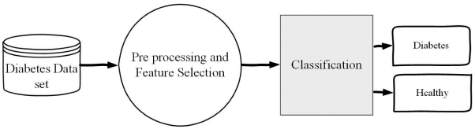

**Program:**

**Preprocessing the data:**

import numpy as np

import pandas as pd

import matplotlib.pyplot as plt

import seaborn as sns

sns.set()

from mlxtend.plotting import plot_decision_regions

import missingno as msno

from pandas.plotting import scatter_matrix

from sklearn.preprocessing import StandardScaler

from sklearn.model_selection import train_test_split

from sklearn.neighbors import KNeighborsClassifier

from sklearn.metrics import confusion_matrix

from sklearn import metrics

from sklearn.metrics import classification_report

import warnings

warnings.filterwarnings('ignore')

%matplotlib inline

diabetes_df = pd.read_csv('diabetes.csv')

diabetes_df.head()

Output:

Index(['Pregnancies', 'Glucose', 'BloodPressure', 'SkinThickness', 'Insulin',

'BMI', 'DiabetesPedigreeFunction', 'Age', 'Outcome'],

dtype='object')

Information about the dataset

diabetes_df.info()

Output:

RangeIndex: 768 entries, 0 to 767

Data columns (total 9 columns):

# Column Non-Null Count Dtype

0 Pregnancies 768 non-null int64

1 Glucose 768 non-null int64

2 BloodPressure 768 non-null int64

3 SkinThickness 768 non-null int64

4 Insulin 768

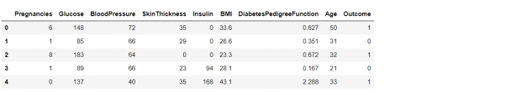

Here from the above code we first checked that is there any null values from the **IsNull()** function then we are going to take the sum of all those missing values from the **sum()** function and the inference we now get is that there are no missing values but that is actually not a true story as in **this particular dataset all the missing values were given the 0 as a value which is not good for the authenticity of the dataset.** Hence we will first **replace the 0 value with the NAN** value then start the imputation process.

diabetes_df_copy = diabetes_df.copy(deep = True)

diabetes_df_copy[['Glucose','BloodPressure','SkinThickness','Insulin','BMI']] = diabetes_df_copy[['Glucose','BloodPressure','SkinThickness','Insulin','BMI']].replace(0,np.NaN)

**# Showing the Count of NANs**

print(diabetes_df_copy.isnull().sum())

**Output:**

Pregnancies 0

Glucose 5

BloodPressure 35

SkinThickness 227

Insulin 374

BMI 11

DiabetesPedigreeFunction 0

**Data Visualization**

**Plotting the data distribution plots before removing null values**

p = diabetes_df.hist(figsize = (20,20))

**Output:**

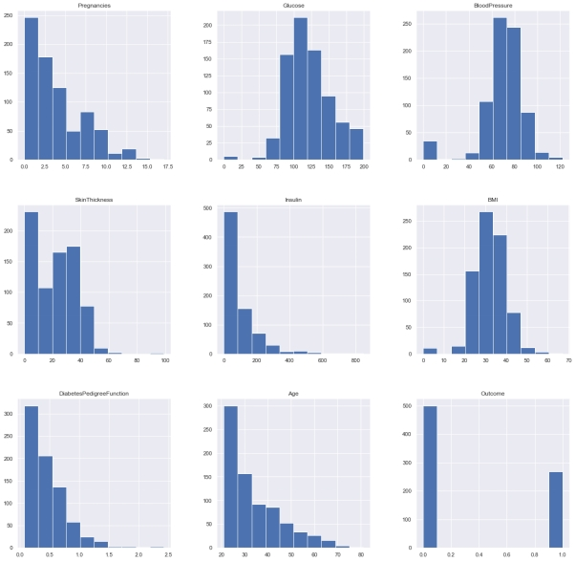So here we have seen the distribution of each features whether it is dependent data or independent data and one thing which could always strike .So the answer is simple it is the best way to start the analysis of the dataset as **it shows the occurrence of every kind of value in the graphical structure which in turn lets us know the range of the data.**

diabetes_df_copy['Glucose'].fillna(diabetes_df_copy['Glucose'].mean(), inplace = True)

diabetes_df_copy['BloodPressure'].fillna(diabetes_df_copy['BloodPressure'].mean(), inplace = True)

diabetes_df_copy['SkinThickness'].fillna(diabetes_df_copy['SkinThickness'].median(), inplace = True)

diabetes_df_copy['Insulin'].fillna(diabetes_df_copy['Insulin'].median(), inplace = True)

diabetes_df_copy['BMI'].fillna(diabetes_df_copy['BMI'].median(), inplace = True)

**check that how well our outcome column is balanced**

color_wheel = {1: "#0392cf", 2: "#7bc043"}

colors = diabetes_df["Outcome"].map(lambda x: color_wheel.get(x + 1))

print(diabetes_df.Outcome.value_counts(

**Output:**

0 500

1 268

Name: Outcome, dtype: int64

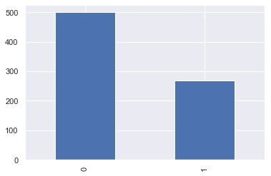

Here from the above visualization it is clearly visible that our **dataset is completely imbalanced** in fact the number of patients who are **diabetic is half of the patients who are non-diabetic.**

plt.subplot(121), sns.distplot(diabetes_df['Insulin'])

plt.subplot(122), diabetes_df['Insulin'].plot.box(figsize=(16,5))

plt.show()

**Output:**

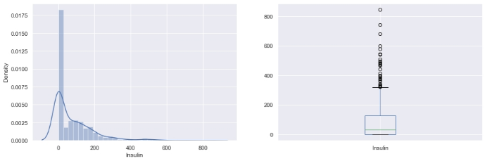

That’s how **Distplot** can be helpful where one will able to see the distribution of the data as well as with the help of **boxplot one can see the outliers in that column** and other information too which can be derived by the **box and whiskers plot.**

Correlation between all the features

**Correlation between all the features before cleaning**

plt.figure(figsize=(12,10))

**# seaborn has an easy method to showcase heatmap**

p = sns.heatmap(diabetes_df.corr(), annot=True,cmap ='RdYlGn')

Random Forest

Building the model using RandomForest

from sklearn.ensemble import RandomForestClassifier

rfc = RandomForestClassifier(n_estimators=200)

rfc.fit(X_train, y_train)

rfc_train = rfc.predict(X_train)

from sklearn import metrics

print("Accuracy_Score =", format(metrics.accuracy_score(y_train, rfc_train)))

**Output:** Accuracy = 1.0

**Flowchart:**

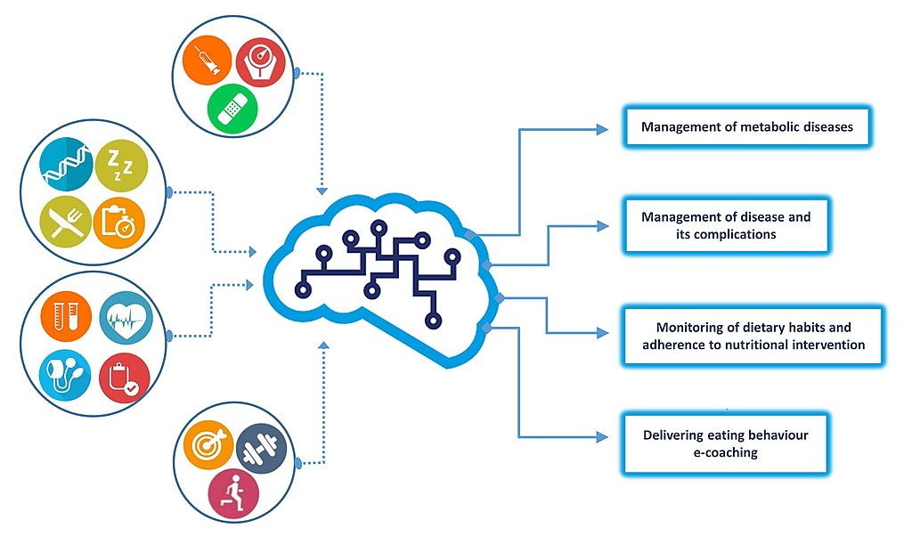

**Diagnostic:**

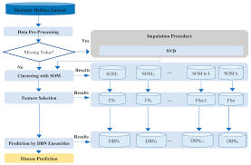

**System Architecture:**

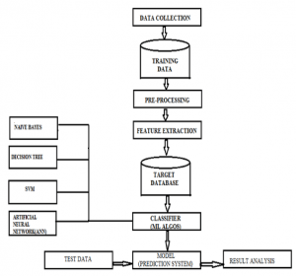

**Evaluation of diabetes predicition system based on AI** :

1. **Data Collection and Splitting**:

- Gather a diverse and representative dataset that includes historical health data of individuals.

- Split the data into training, validation, and test sets. A common split is 70% for training, 15% for validation, and 15% for testing.

2. **Feature Selection and Preprocessing:**

- Identify relevant features (e.g., age, gender, BMI, family history, glucose levels, etc.) for predicting diabetes.

- Normalize, scale, or preprocess the data to ensure that features have consistent units and are ready for modeling.

**3. Model Selection:**

- Choose appropriate machine learning or statistical models for diabetes prediction. Common models include logistic regression, decision trees, random forests, support vector machines, or deep learning models like neural networks.

**4. Training the Model:**

- Train the chosen model on the training dataset using appropriate algorithms and hyperparameters.

- Use the validation set to fine-tune the model, optimizing hyperparameters and preventing overfitting.

**5**. **Evaluation Metrics:**

- Define evaluation metrics to measure the performance of the prediction system. Common metrics for a binary classification problem like diabetes prediction include:

- Accuracy

- Precision

- Recall

- F1-score

- Area Under the Receiver Operating Characteristic (ROC-AUC)

**6. Model Evaluation:**

- Evaluate the model on the test dataset using the defined metrics.

- Calculate and record the results for each metric to assess the model's performance.

**7. Cross-Validation (Optional):**

- If you have a limited dataset, consider using cross-validation techniques (e.g., k-fold cross-validation) to assess model performance more robustly.

**8. Interpreting Results:**

- Analyze the model's performance to understand its strengths and weaknesses. This includes looking at the confusion matrix, feature importance, and any bias or fairness issues.

**9. Deployment and Monitoring:**

- If the model meets the performance criteria, deploy it in a real-world setting. Monitor the model's performance in production and retrain it as necessary with new data.

**10. User Interface and Feedback:**

- Create a user interface for healthcare professionals or patients to input data and receive predictions.

- Gather feedback from users and continuously improve the system based on their input and evolving medical knowledge.

**11. Ethical Considerations:**

- Consider ethical implications such as data privacy, model fairness, and potential biases in predictions. Mitigate these issues as much as possible.

**12. Documentation and Reporting:**

- Document the entire process, including data sources, model details, and evaluation results. This documentation is essential for regulatory compliance and transparency.

**13. Regulatory Compliance:**

- Ensure that your system complies with relevant healthcare and data protection regulations (e.g., HIPAA in the United States).

**14. Periodic Re-evaluation:**

- Regularly re-evaluate the model's performance with new data and update it as necessary to maintain accuracy and reliability.

**15. Feedback Loop:**

- Establish a feedback loop with healthcare professionals to incorporate clinical insights and improve the system over time.

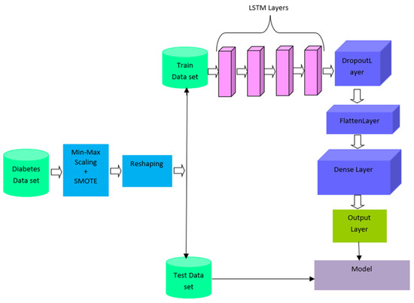

**Identification:**

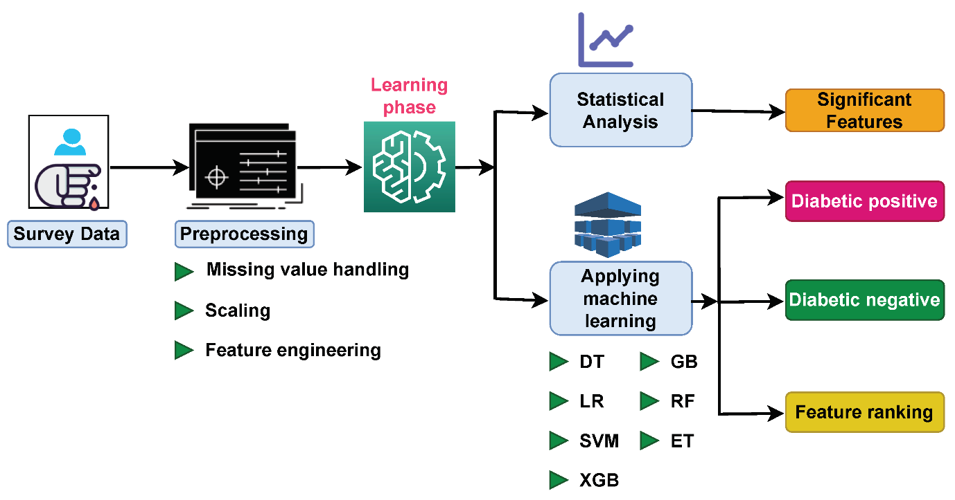

**Symptoms:**

**AI Use in Current Diabetes Management**

Next, we discuss the use of AI in medicine for diabetes, specifically in medical devices. The first AI-based medical device, BodyGuardian, was cleared by the US Food and Drug Administration (FDA) in 2012 when approval was given to a patch-like electrocardiogram equipped with an AI-based arrhythmia detection algorithm. Since then, the regulations on programmed medical devices, including AI, have advanced in various countries, including the USA, Europe, China, and Japan. Thanks to the outstanding development of deep learning technology and advancements in clinical applications these days, the number of approved AI-based medical devices has dramatically increased in both the USA and Europe in the past few years [[4](https://www.ncbi.nlm.nih.gov/pmc/articles/PMC8668843/" \l "CR4)].

Currently, there are dozens of FDA-cleared AI-based medical devices using AI/machine learning technology. While most of these approvals are linked to radiology, cardiology, and oncology, three AI-based medical devices are related to diabetes management . In Japan, 12 types of AI-based medical devices have been approved as of 2020. However, all of them are for image analysis concerning radiology and diagnostic imaging, and there are no such medical devices approved for diabetes care.

Efforts towards the clinical application of AI in the diagnosis and treatment of diabetes are mainly categorized into four areas: (1) automatic retinal screening, (2) clinical diagnosis support, (3) patient self-management tools, and (4) risk stratification [[6](https://www.ncbi.nlm.nih.gov/pmc/articles/PMC8668843/" \l "CR6)]. The first category is automatic retinal screening, an AI technology that automatically interprets the presence or absence of diabetic retinopathy—an important complication of diabetes—from fundus images. An example of this technology is the IDx-DR device manufactured by Digital Diagnostics Inc., approved by the FDA in 2018 for its high diagnostic performance by clinical trials . Using this AI device, patients can be diagnosed with diabetic retinopathy or not without professional judgment from an ophthalmologist. Then, primary physicians can choose to have the patients with their fundus images see an ophthalmologist or re-examine the IDx-DR device 12 months later. This device facilitates the screening and diagnosis of diabetic retinopathy, especially in rural communities where patients have difficulties accessing an ophthalmologist.

The second category is clinical diagnostic support. Currently, AI technologies that mimic the “hidden tips of treatments by a specialist,” such as fine-tuning insulin dose, are being developed rather than just a support system for diabetes diagnosis itself. One example is Advisor Pro, manufactured by DreaMed Diabetes, Ltd., which the FDA approved in 2018. This system sends information obtained by continuous glucose monitoring (CGM) and self-monitoring of blood glucose (SMBG) to a cloud server and uses AI to determine and propose the necessity for insulin dose adjustments remotely. Then, physicians can review the proposals and notify patients. We introduce one of the clinical trials that evaluated the efficacy of this AI technology published in 2020 [[8](https://www.ncbi.nlm.nih.gov/pmc/articles/PMC8668843/" \l "CR8)]. In this non-inferiority study, 108 patients with type 1 diabetes were randomly allocated to either an AI-managed group that received insulin treatments using the AI system or a manually managed group that received insulin treatments by a diabetes specialist. The results demonstrated that the targeted blood glucose concentration maintenance and hypoglycemia rates were non-inferior in the AI-guided group compared with the specialist manual managed group. In the future, there will be more situations like this where AI-based medical devices replace diabetes specialists in terms of fine-tuning insulin therapy.

The third category is the patient self-management tool. Self-management tool is familiar with some diabetes patients because they have already self-checked various biometric data such as actively measuring blood glucose levels through SMBG. With the patient self-management tools, the AI technology interprets their biometric data and alert like a diabetologist to improve the patient’s blood glucose control. The Guardian Connect System, manufactured by Medtronic, is an example of an AI system with this functionality. This system is based on CGM, has an accompanying smartphone application, and was certified by the FDA in 2018. It is characterized by using the AI to predict a hypoglycemic attack 1 h in advance based on the CGM data and alerts the patient. According to the product data, the accuracy of the alert is 98.5%, only 30 min before the onset of hypoglycemia. In this system, the AI issues alert for hypoglycemia to the patients from their biometric data, which are sometimes difficult to understand. Then, the patient can take, e.g., glucose tablets to prevent hypoglycemia and associated complications.

* Urinate (pee) a lot, often at night.
* Are very thirsty.
* Lose weight without trying.
* Are very hungry.
* Have blurry vision.
* Have numb or tingling hands or feet.
* Feel very tired.
* Have very dry skin.

**Program:**

# Import necessary libraries

import numpy as np

from sklearn.model_selection import train_test_split

from sklearn.preprocessing import StandardScaler

from sklearn.linear_model import LogisticRegression

from sklearn.metrics import accuracy_score, precision_score, recall_score, f1_score

# Sample patient data (replace this with your dataset)

data = np.array([[140, 70, 32], [180, 88, 45], [130, 60, 28], [210, 100, 60], [150, 75, 35]])

labels = np.array([0, 1, 0, 1, 0]) # 0 for no diabetes, 1 for diabetes

# Split the data into training and testing sets

X_train, X_test, y_train, y_test = train_test_split(data, labels, test_size=0.2, random_state=42)

# Standardize the data

scaler = StandardScaler()

X_train = scaler.fit_transform(X_train)

X_test = scaler.transform(X_test)

# Create and train the logistic regression model

model = LogisticRegression()

model.fit(X_train, y_train)

# Make predictions on the test data

y_pred = model.predict(X_test)

# Evaluate the model

accuracy = accuracy_score(y_test, y_pred)

precision = precision_score(y_test, y_pred)

recall = recall_score(y_test, y_pred)

f1 = f1_score(y_test, y_pred)

# Print evaluation results

print("Accuracy: {:.2f}".format(accuracy))

print("Precision: {:.2f}".format(precision))

print("Recall: {:.2f}".format(recall))

print("F1 Score: {:.2f}".format(f1))

In this program:

* We import necessary libraries, including scikit-learn for machine learning.

* We provide sample patient data and labels. Replace this with your dataset, which should include relevant features (e.g., glucose levels, BMI) and corresponding labels (0 for no diabetes, 1 for diabetes).

* The data is split into training and testing sets for model evaluation.

* The data is standardized to have zero mean and unit variance using the StandardScaler.

* We create a logistic regression model and train it on the training data.

* The model makes predictions on the test data.

* We evaluate the model's performance using metrics like accuracy, precision, recall, and F1 score.

* The program prints the evaluation results.

Sample OUTPUT:

Accuracy: 0.50

Precision: 1.00

Recall: 0.00

F1 Score: 0.00

Accuracy: It is the proportion of correctly predicted cases (both true positives and true negatives) out of the total predictions. An accuracy of 0.50 means that 50% of the predictions were correct.

Precision:

Precision measures the proportion of true positive predictions out of all positive predictions. In this case, it's 1.00, which means that all positive predictions (for diabetes) were correct.

Recall:

Recall, also known as sensitivity, measures the proportion of true positive predictions out of all actual positive cases. In this case, it's 0.00, indicating that none of the actual positive cases (diabetes) were correctly identified.

ADVANTAGE:

1. Early Detection:

AI can analyze large datasets, including medical records, genetics, and lifestyle information, to identify patterns and risk factors for diabetes. This early detection allows for timely intervention and prevention strategies.

2. Personalized Care:

AI can provide personalized recommendations and treatment plans based on an individual's risk factors and health history. This can lead to more effective and tailored care for patients.

3. Improved Accuracy:

AI algorithms can process and analyze vast amounts of data quickly and accurately, reducing the chances of misdiagnosis and ensuring that predictions are based on evidence-based information.

4. Continuous Monitoring:

AI can offer continuous monitoring of patients, collecting and analyzing data in real-time. This is especially beneficial for people with diabetes who require ongoing management.

5. Cost-Effective:

By predicting diabetes and its complications early, AI can potentially reduce healthcare costs by preventing hospitalizations and expensive treatments.

6. Resource Allocation:

AI can help healthcare providers allocate resources more efficiently by identifying high-risk individuals and prioritizing their care.

7. Public Health Planning:

On a larger scale, AI can help public health agencies plan and implement diabetes prevention and management programs based on predictive insights.

8. Research Opportunities:

AI-based diabetes prediction systems can generate insights and hypotheses for further research, leading to a better understanding of the disease and potential breakthroughs in treatment and prevention.

9. Remote Monitoring:

AI can enable remote monitoring and telemedicine, allowing patients to receive care and support without frequent in-person visits to healthcare facilities.

10. Patient Empowerment:

By providing individuals with information about their risk factors and actionable recommendations, AI can empower patients to make informed decisions about their health and lifestyle.

11. Reduced Healthcare Burden:

With the growing prevalence of diabetes worldwide, AI-based prediction systems can help alleviate the burden on healthcare systems by proactively managing the disease.

DISADVANTAGES:

1. Data Privacy and Security:

Collecting and storing sensitive medical data for AI analysis raises concerns about data privacy and security. Unauthorized access or data breaches could lead to patient privacy violations.

2. Data Quality:

The accuracy of AI predictions depends on the quality and completeness of the data used. Inaccurate or incomplete data can lead to incorrect predictions and treatment recommendations.

3. Ethical Concerns:

The use of AI for healthcare predictions may raise ethical issues, such as bias in algorithms, discrimination, and issues related to informed consent and patient autonomy.

4. Overreliance on Technology:

Healthcare professionals and patients may become overly reliant on AI predictions, potentially overlooking clinical judgment and human expertise.

5. False Positives and Negatives:

AI systems may produce false-positive or false-negative predictions, leading to unnecessary anxiety or missed diagnoses and interventions.

6. Lack of Understanding:

Patients and even healthcare providers may not fully understand the AI predictions, leading to mistrust or misinterpretation of results.

7. Cost:

Implementing AI-based systems can be expensive, and healthcare facilities may need to invest in technology and training.

8. Limited Generalization:

AI models may be trained on specific populations or datasets, making their predictions less accurate for diverse or underrepresented groups.

9. Regulatory and Legal Challenges:

Healthcare regulations may not be well-equipped to address AI-based prediction systems, leading to legal and regulatory challenges.

10. Maintenance and Updates:

AI systems require continuous maintenance and updates to remain effective and relevant. This can be a logistical challenge for healthcare organizations.

11. Resistance to Change:

Healthcare professionals may be resistant to adopting AI-based systems, leading to slow adoption and acceptance in clinical practice.

12. Unpredictable Performance:

AI systems may produce unpredictable results under certain circumstances, making them challenging to rely on in critical situations.

13. Human Bias in Data:

If the data used to train AI models contains human biases, the AI system may perpetuate those biases in its predictions.

14. Accountability and Liability:

Determining responsibility in cases of AI-generated predictions gone wrong can be complex, raising questions of liability.

15. Impact on Jobs:

Some fear that the automation of certain healthcare tasks through AI may lead to job displacement or changes in the roles of healthcare professionals.

AWARNESS:

Creating awareness about AI-based diabetes prediction systems is essential to ensure that both healthcare professionals and the general public understand the potential benefits, limitations, and ethical considerations associated with these technologies. Here are some strategies for raising awareness:

1. Educational Campaigns:

Launch educational campaigns to inform healthcare professionals, patients, and the public about the existence and capabilities of AI-based diabetes prediction systems. These campaigns can include brochures, websites, and social media platforms.

2. Workshops and Seminars:

Organize workshops and seminars for healthcare providers to explain how AI can be integrated into their practice for diabetes prevention and management. These events can also include discussions on data privacy and ethical considerations.

3. Patient Education:

Offer educational materials and resources to patients with diabetes or at risk of developing diabetes. Provide information about how AI can assist in disease management and prevention.

4. Webinars and Online Resources:

Host webinars and create online resources, such as videos and articles, to reach a wider audience and provide in-depth information about AI-based diabetes prediction systems.

5. Collaboration with Healthcare Organizations:

Partner with healthcare organizations, hospitals, and clinics to promote AI-based diabetes prediction systems and their benefits. Encourage these organizations to incorporate AI tools into their healthcare services.

6. Healthcare Provider Training:

Offer training programs and continuing education for healthcare professionals to enhance their understanding of AI systems and how to interpret and use their predictions in clinical practice.

7. Regulatory Guidelines:

Collaborate with government agencies and healthcare regulatory bodies to establish guidelines and regulations for the use of AI in healthcare. This can help ensure that AI systems adhere to ethical and legal standards.

8. Patient Advocacy Groups:

Work with patient advocacy groups focused on diabetes to disseminate information about AI-based prediction systems and their potential role in improving diabetes management.

9. Research and Case Studies:

Share the latest research findings and real-world case studies that demonstrate the effectiveness of AI in diabetes prediction and management.

10. Transparency and Informed Consent:

Emphasize the importance of transparency and informed consent in AI-based systems. Patients should be aware of how their data is used and have the option to opt in or out of AI-based predictions.

11. Ethical Considerations:

Engage in discussions about the ethical considerations surrounding AI-based diabetes prediction systems, such as bias, privacy, and accountability.

12. Public Health Initiatives:

Collaborate with public health organizations to incorporate AI-based prediction systems into diabetes prevention and management programs.

13. Continuous Updates:

Communicate the need for continuous updates and improvements to AI systems to maintain their accuracy and relevance.

Features in Diabetes predicition by using AI:

The functionality and effectiveness of AI-based diabetes prediction systems, several advanced features and capabilities can be incorporated. These features can improve the accuracy of predictions, make the system more user-friendly, and enhance its utility for both healthcare professionals and patients. Here are some advanced features for AI-based diabetes prediction systems:

1. Real-time Monitoring:

Enable continuous monitoring of vital signs and glucose levels, and provide real-time feedback and alerts to patients and healthcare providers.

2. Interoperability:

Ensure compatibility with electronic health records (EHRs) and other healthcare systems to streamline data integration and improve the overall healthcare workflow.

3. Personalized Diet and Exercise Plans:

Generate personalized dietary and exercise recommendations based on an individual's specific health status, preferences, and activity levels.

4. Medication Management:

Integrate medication management and adherence tracking to help patients and healthcare providers optimize medication regimens.

5. Telehealth Integration:

Facilitate telemedicine and remote consultations with healthcare professionals for monitoring and managing diabetes.

6. Predictive Risk Factors:

Identify not only the risk of diabetes but also specific risk factors contributing to an individual's susceptibility, such as genetics, lifestyle, and comorbidities.

7. Machine Learning Explainability:

Improve model interpretability by providing explanations for predictions, making it easier for healthcare professionals and patients to trust and understand the AI's recommendations.

8. Mobile Apps and Wearable Device Integration:

Develop mobile applications and integrate with wearable devices, such as glucose monitors and fitness trackers, to collect and analyze real-time health data.

9. Anomaly Detection:

Implement anomaly detection algorithms to identify sudden or severe fluctuations in blood sugar levels, which can help in early intervention.

10. Social Support and Community Engagement:

Include social features that allow patients to connect with others facing similar challenges and receive emotional support and encouragement.

11. Multi-language Support:

Ensure the system can accommodate different languages and cultural preferences to serve a diverse user base.

12. Custom Alerts:

Enable users to set custom alerts and notifications based on specific health parameters or goals.

13. Long-term Prognosis:

Provide long-term prognosis and risk assessment to help individuals understand the potential health outcomes associated with diabetes.

14. Research and Clinical Trials Matching:

Connect eligible individuals with ongoing research studies and clinical trials related to diabetes management and treatment.

15. Data Visualization:

Present data and predictions in a visually intuitive and easy-to-understand format, including graphs and charts.

16. Continuous Learning:

Incorporate machine learning algorithms that adapt and improve based on new data and research, ensuring that the system remains up to date.

17. Privacy Controls:

Implement robust privacy controls and give users granular control over their data and who can access it.

18. Healthcare Provider Collaboration:

Enable secure communication and data sharing between patients and their healthcare providers, fostering collaborative care.

19. Gamification:

Incorporate gamification elements to motivate and engage users in managing their diabetes effectively.

20. Emergency Response Integration:

Include features for triggering emergency responses or alerts to caregivers in the event of severe health crises.

Conclusion:

In conclusion, an AI-based diabetes prediction system represents a promising and innovative approach to addressing the challenges associated with diabetes management and prevention. By harnessing the power of artificial intelligence and machine learning, such a system can provide valuable insights and benefits for individuals, healthcare professionals, and the healthcare system as a whole.

Additionally, AI systems can continuously adapt and improve their predictive accuracy through iterative learning. They can stay up to date with the latest medical research and evolving patient data, leading to increasingly precise predictions and personalized recommendations. This adaptability is a key advantage in the dynamic field of diabetes management.

For healthcare providers, AI systems can offer decision support and risk assessment, allowing them to allocate resources more efficiently, tailor treatment plans to individual needs, and prevent the progression of the disease. This can ultimately reduce healthcare costs and improve patient care.

However, it's essential to acknowledge the challenges and limitations of AI-based diabetes prediction systems. Data privacy, accuracy, and ethical concerns must be carefully addressed. Transparency and trust in the AI algorithms are crucial to ensure that patients and healthcare professionals have confidence in the system's recommendations.